Technical Development Program for
Process Performance Engineers

Clinker Uniformity
Case Study
Part B
Raw Material Preparation

Version 18th of Apr 2016
LafarageHolcim Ltd.
Cement Industrial Performance
Raw material mining and handling

Raw material composition

Material | Source | Comments | Avg. use in raw mix  [%] | Moisture  [%]
CR Limestone | Own, but external quarry, transported by barges on the sea |  | 81.3 | 10.8
Vulcan Limestone | External supplier, transported by barges | Used in small quantities, sweetener, | 3.6 | 8.9
Fly ash | Various sources |  | 9.6
Sand | Natural, wet |  | 2.7 | 8.4
Iron correctives |  |  | 0.5
Various alternative raw materials |  |  | 2.3

CR Limestone

Excavation
CR limestone is excavated from pits with a drag chain. It is a soft, chalk-like limestone. It is contaminated with pockets of sand. No selective quarrying is possible. Excavated limestone is deposited for several weeks along the ponds for draining the water. These heaps are then reclaimed and conveyed – passing through a PGNAA – to the barge loading station. Inadequate quality (high SiO₂-content) can be deviated to an intermediate stockpile, from where it can be reclaimed back when the SiO₂-level of limestone from the pond-heaps allows for it. Barges carrying about 29’000 t are used to transport the limestone to the plant.

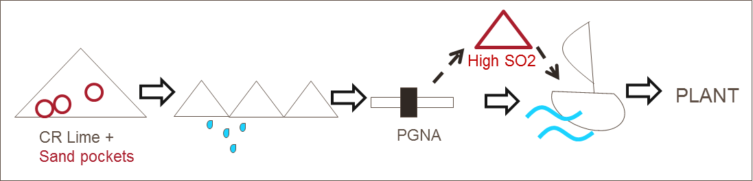

Annex B.1 shows the quality of barge loads brought to the plant, for the year 2001 (no PGNAA) and the year 2005 (with PGNAA).

Storage at plant
The CR limestone is stored on a 2 x 45’000 t longitudinal bed (“active” stockpile). Stacking is in chevron type; reclaiming is by side reclaimer. Additional area for limestone is available adjacent to the active stockpile

Vulcan limestone
Vulcan limestone (consistently high grade quality) is imported and used in smaller quantities in the raw mix to complement the CR limestone and to overcome situations of too low grade CR limestone.

Sand
Sand of uniform, high SiO₂-quality is purchased and stockpiled at the plant (see Annex B.3).

Drying
The CR limestone (avg. 10 % moisture) requires drying in rotary dryers.

Also the wet sand (avg. 8 % moisture) is presently dried in the rotary dryers. (An attempt to store wet sand in a feed silo and directly feed it to the grinding system caused problems with reclaiming from the silo and was abandoned.)

Drying of limestone and sand is being done alternatingly. Storage of the dried materials and dust from the dryers is as follows.

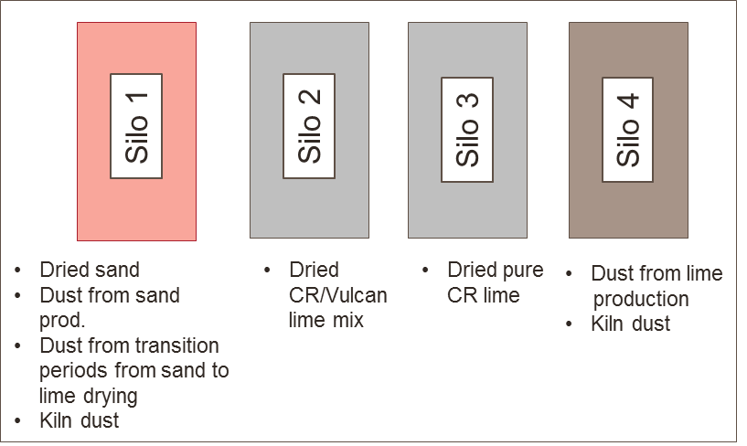

Resulting raw material qualities and proportioning in raw mix
Raw material qualities are regularly determined on spot samples taken at the exit of the storage silos (feed to raw grinding system).
The statistics over one year are given in annex B.2.
Annex B.3 provides additional details on the sand quality as received and as extracted from the silo after drying, respectively.

Typical raw component proportioning at the grinding system over a period of a week are shown in Annex B.4

Task B
Address the following questions.
- Is the uniformity of the limestone at the stage of the feed silos to the grinding system sufficient?
- What measures would you suggest to improve the limestone uniformity? Name in total min. two measures (organisational and/or installation wise) Hint: draw a sketch of the pre-blending bed and the reclaiming set-up
- What are the impacts on uniformity on drying sand in the rotary dryers? Hint: compare barge load data and annual results after silos
- What technical modification would you suggest to achieve higher uniformity? (explain at least one)

Annex B.1a: Composition of CR limestone as shipped to the plant (previous investigation 2001; samples analysed at off-loading at the plant)
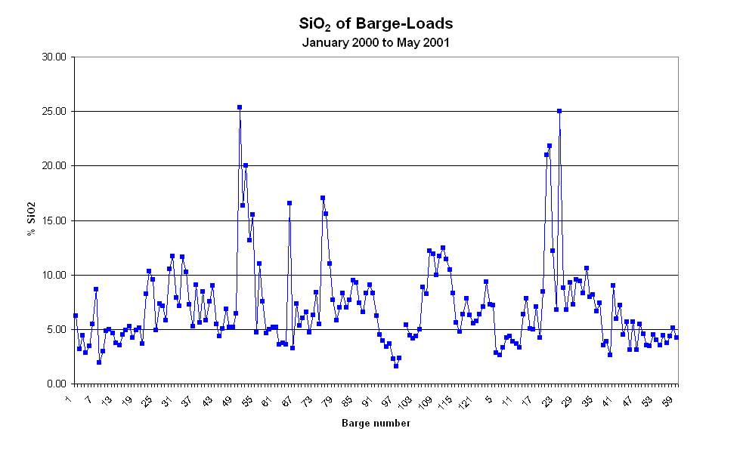

Annex B.1b: Composition of CR limestone as shipped to the plant (2005; analysed by PGNAA at loading in the quarry)

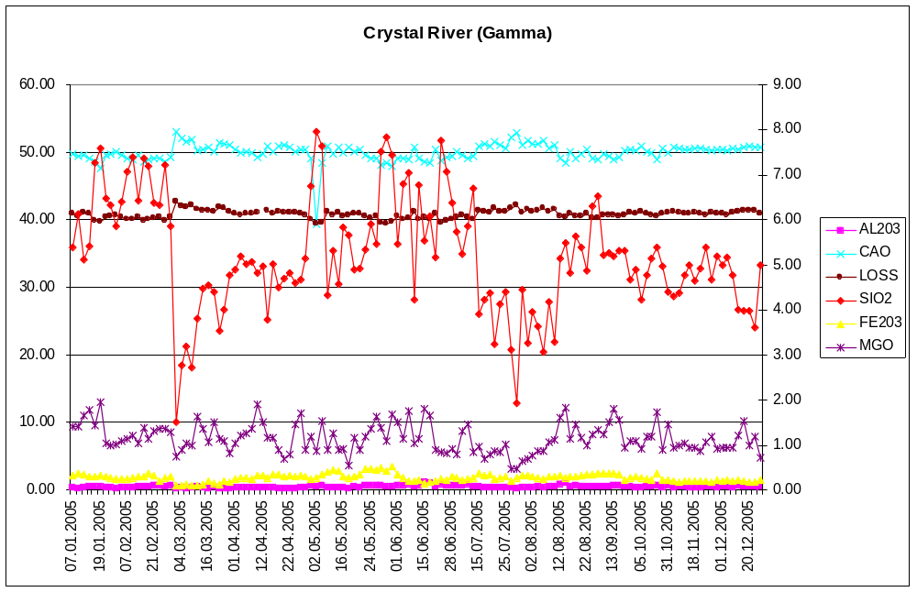
Annex B.2: Composition of raw materials at outlet of feed silos

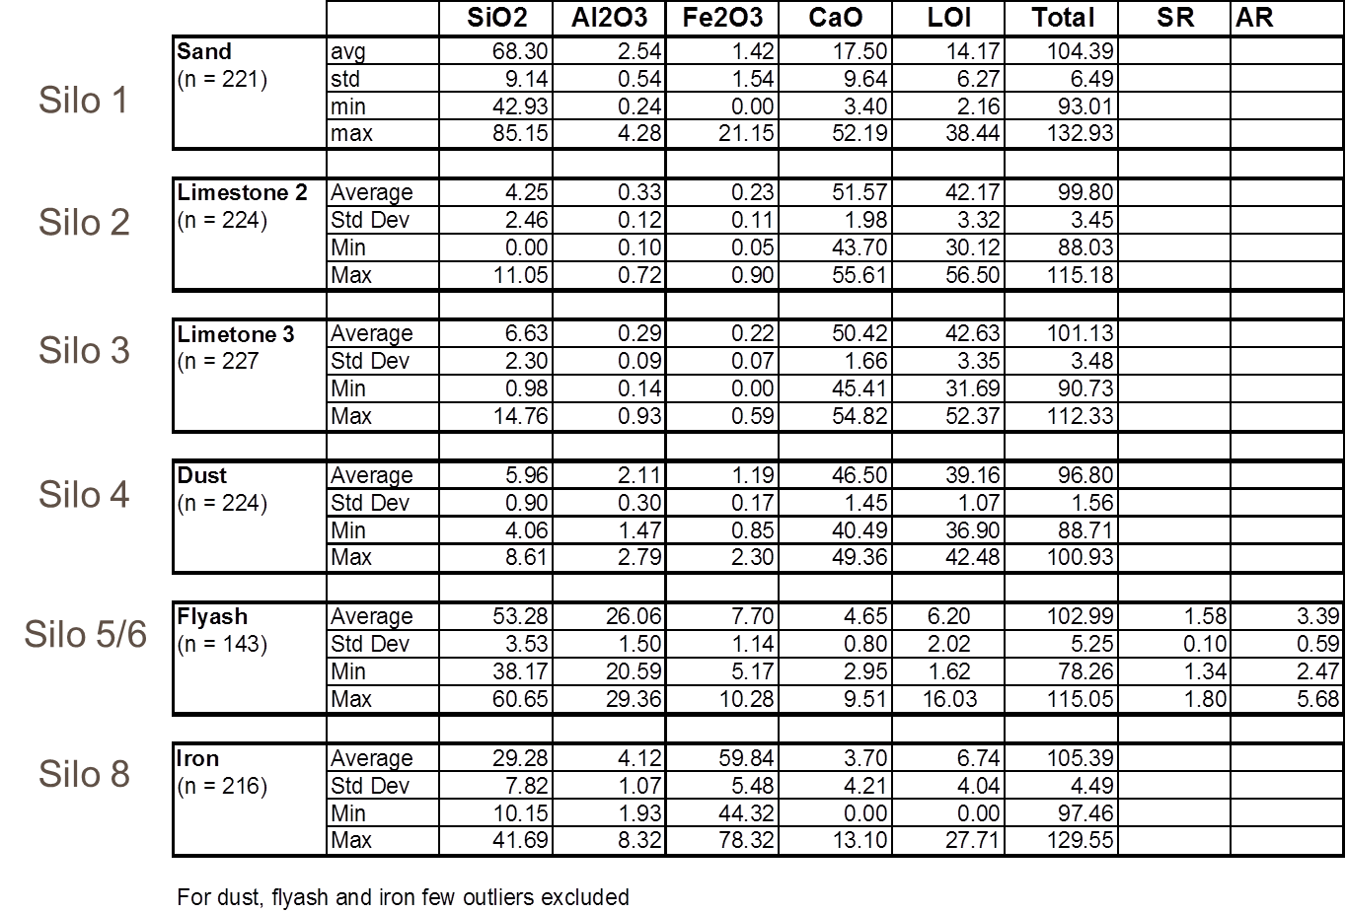

Annex B.3: Details of sand composition

As received

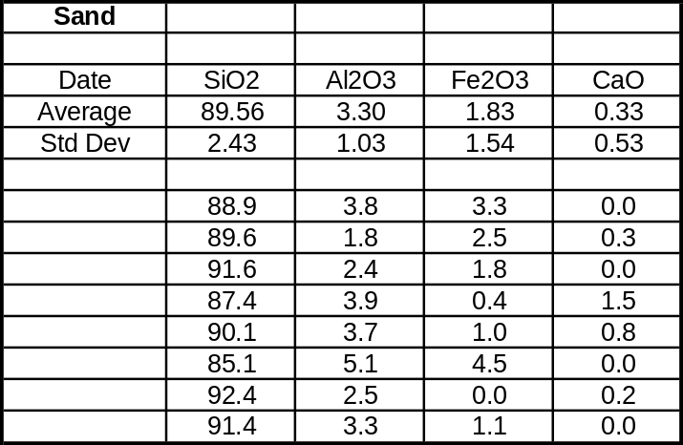

Annex B.4: Example of feeder variability

